**Section 1:**

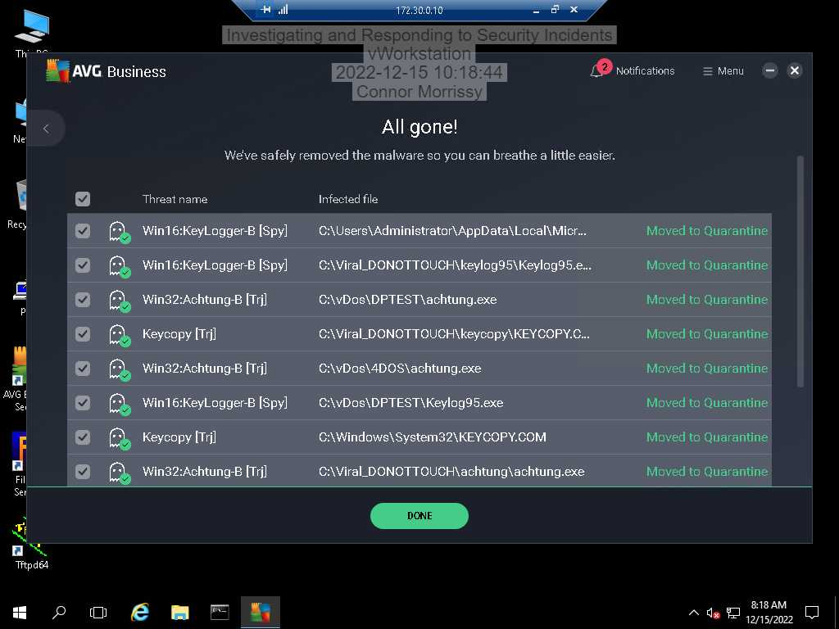

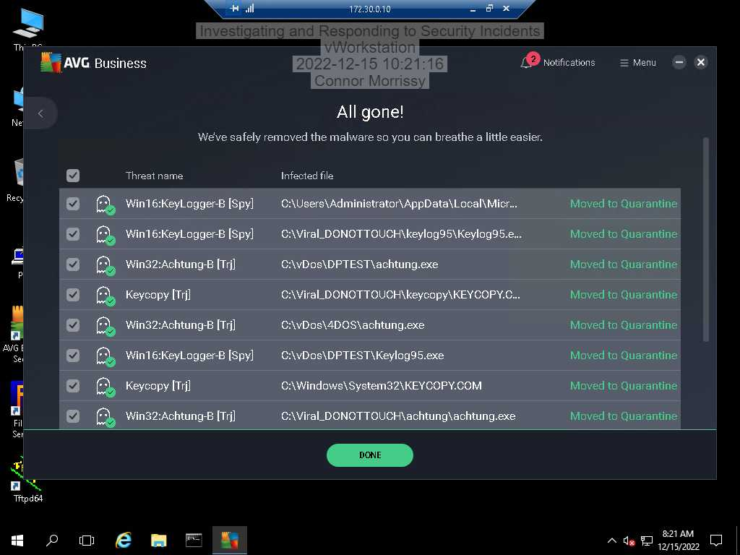

(3rd, 5th, and 8th listing)

“Most achtung.exe errors are the result of missing or corrupt versions of the executable file, and commonly encountered at Hacker's Handbook program launch. The primary way to resolve these problems manually is to replace the EXE file with a fresh copy. As a supplemental troubleshooting step, we highly recommend cleaning up any invalid file path and EXE file extension references that could contribute to creating these achtung.exe error messages.”

From: https://www.solvusoft.com/en/files/error-virus-removal/exe/windows/dark-bay-ltd/hacker-s-handbook/achtung-exe/

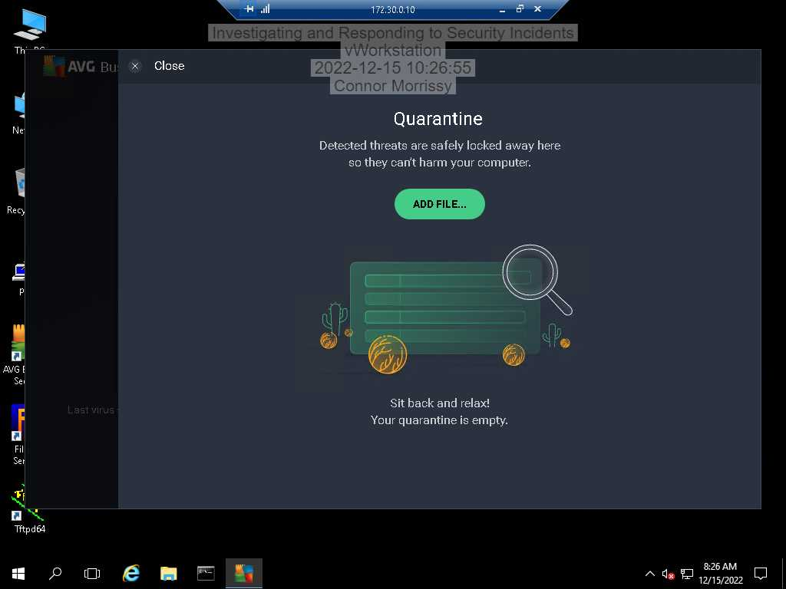

**Section 2:**

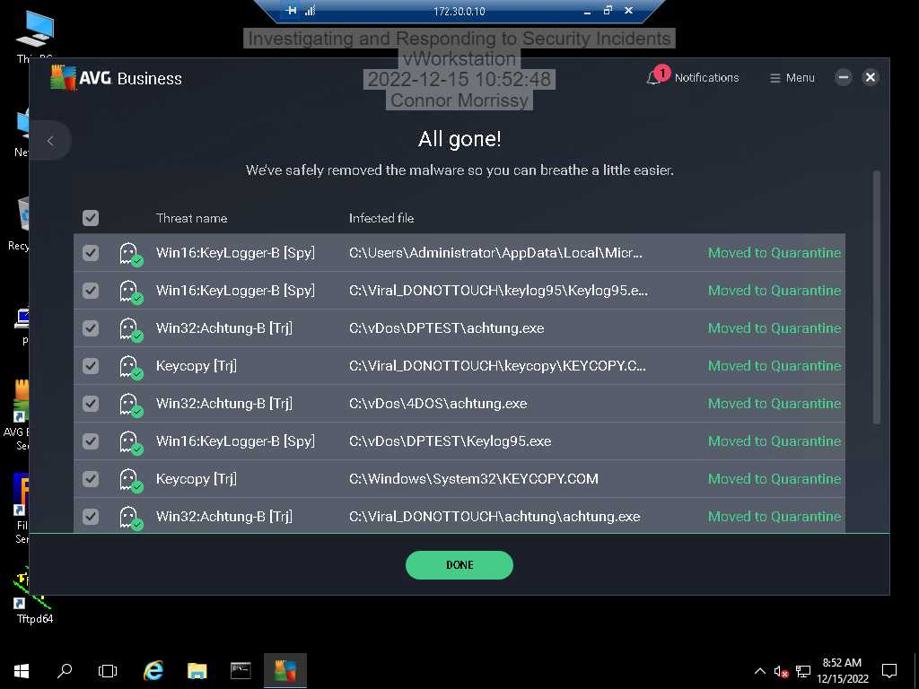

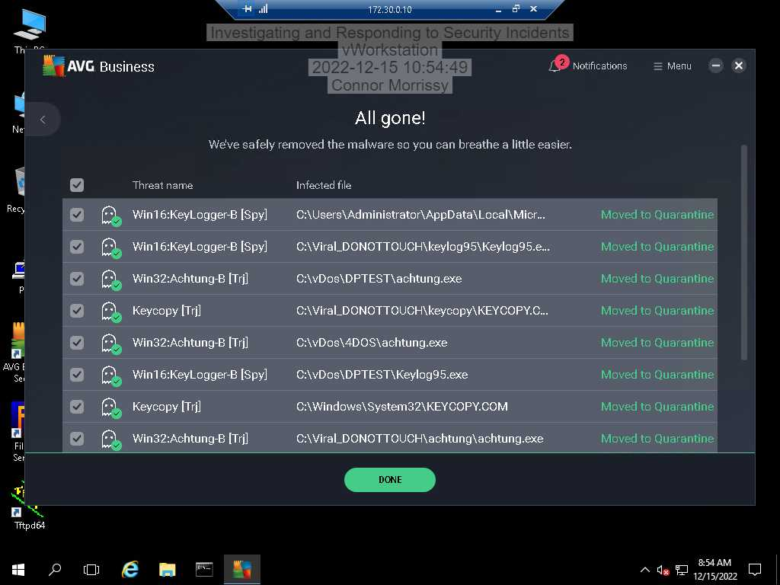

(4th and 7th listing)

Microsoft recommends using Windows Defender or equivalent to detect and remove the threat, run a full scan to check for more threats, and then recommends changing passwords afterward.

From: https://www.microsoft.com/en-us/wdsi/threats/malware-encyclopedia-description?Name=TrojanSpy:DOS/Keycopy&threatId=-2147468452

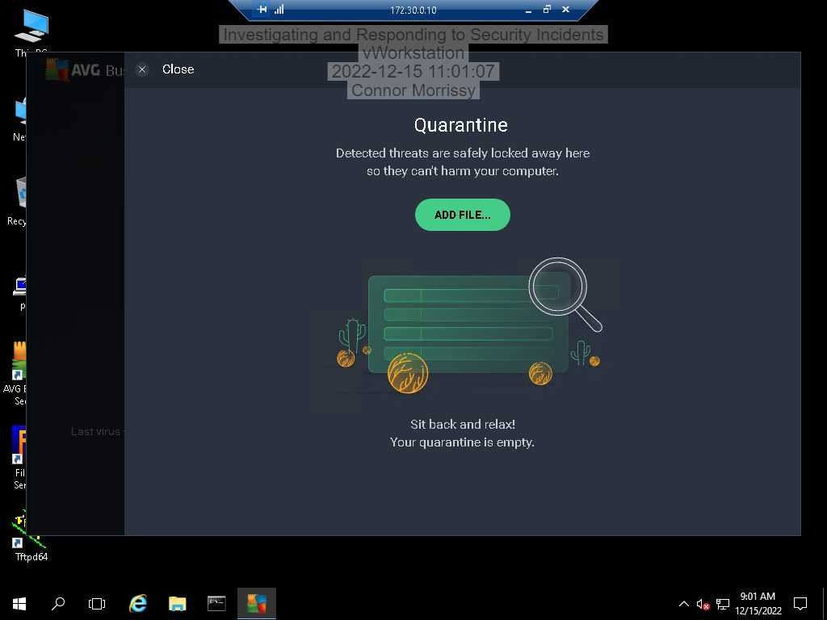

**Section 3:**

Part 1: Air-gapping an infected system ensures that the infection does not spread to the rest of the network. Connecting to a secure update server puts that server at risk.

Part 2: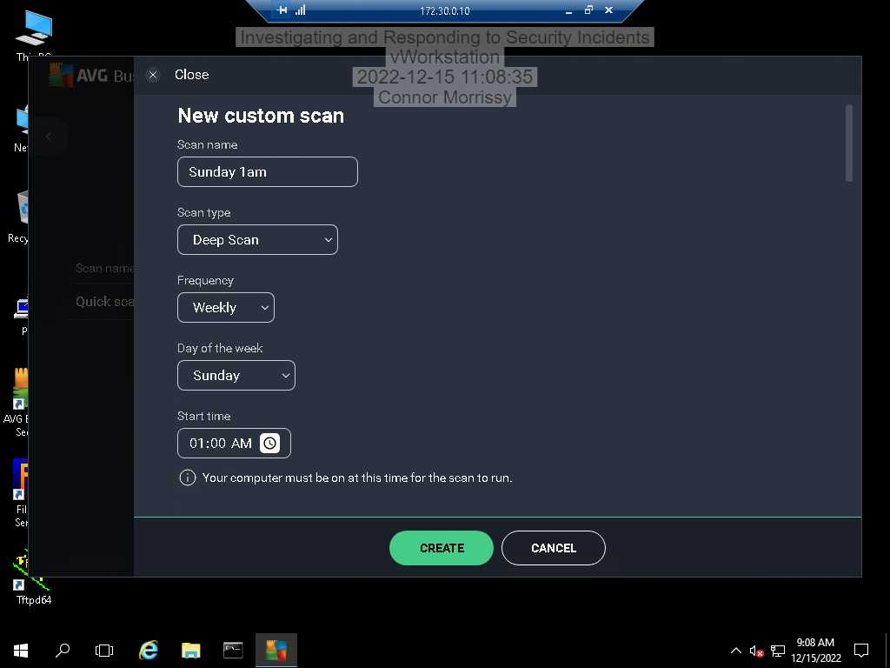

Part 3:

I would absolutely make sure that each individual computer is not infected using anti-virus and take the steps needed to eradicate any infection if there is one. Once a computer is ensured to be clean and safe, then the machine can be reintroduced to the network.